|  |  |  |
| --- | --- | --- |
| Name | Iteration | Dates |
| Mel Chi | 1 | 9/17-9/24 |
| Mel Chi | 2 | 9/24-10/1 |
| Mel Chi | 3a | 10/1-10/08 |
| Mel Chi | 3b | 10/08-10/15 |

10/15/2015 Updated Gant Chart

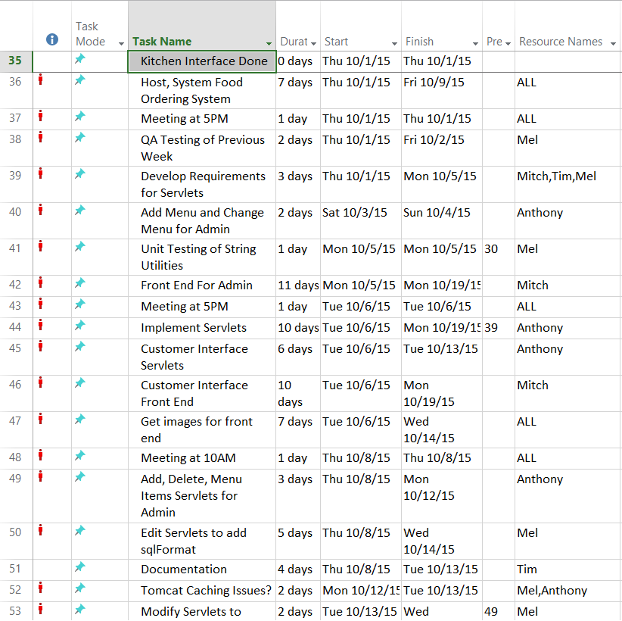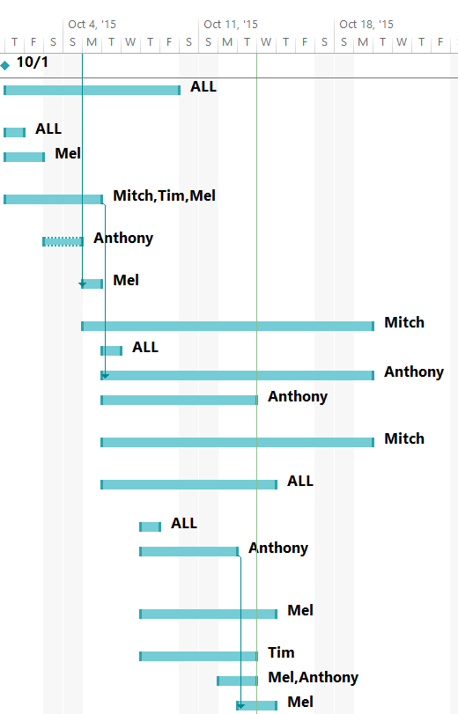

10/1/2015

Updated Gant Chart is given.

Added final milestone to the chart

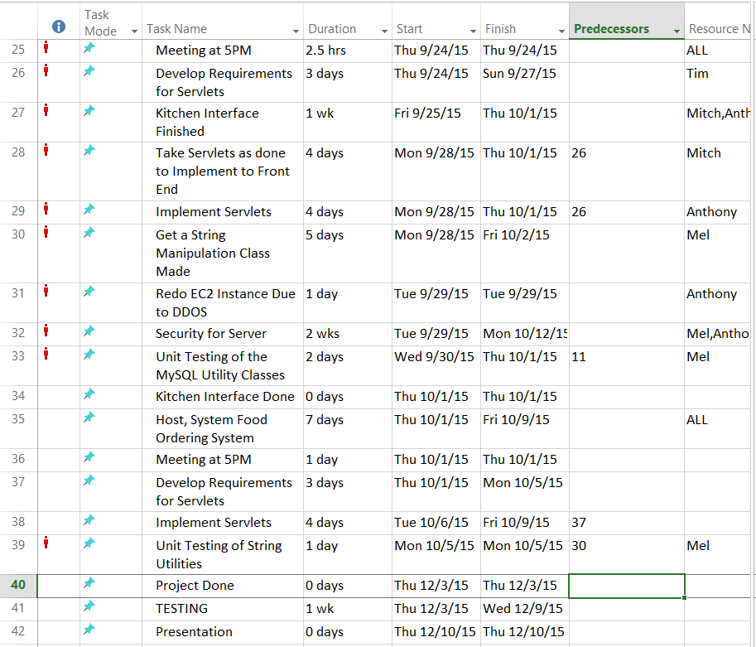

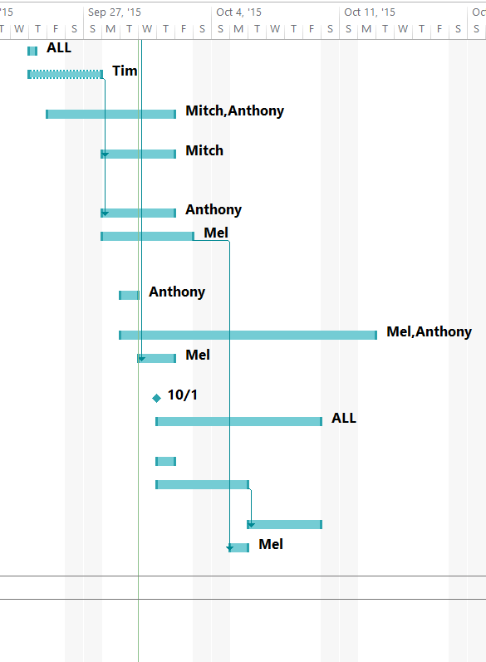

9/29/2015

Server was used to DDOS attacked. Needed Anthony to create another EC2 Instance, Will work On security Immediately, Will probably look to the professor for idea. Assigned Documentation

9/24/2015

Assigned Documentation and Requirements to Tim

Assigned Project Manager to Mel

Assigned Development Roles to Mel, Anthony, and Mitch

9/23/2015

Schedule completed updated and moved bug fix days from a week to a day,

and pushed up Kitchen Interface need to be finished

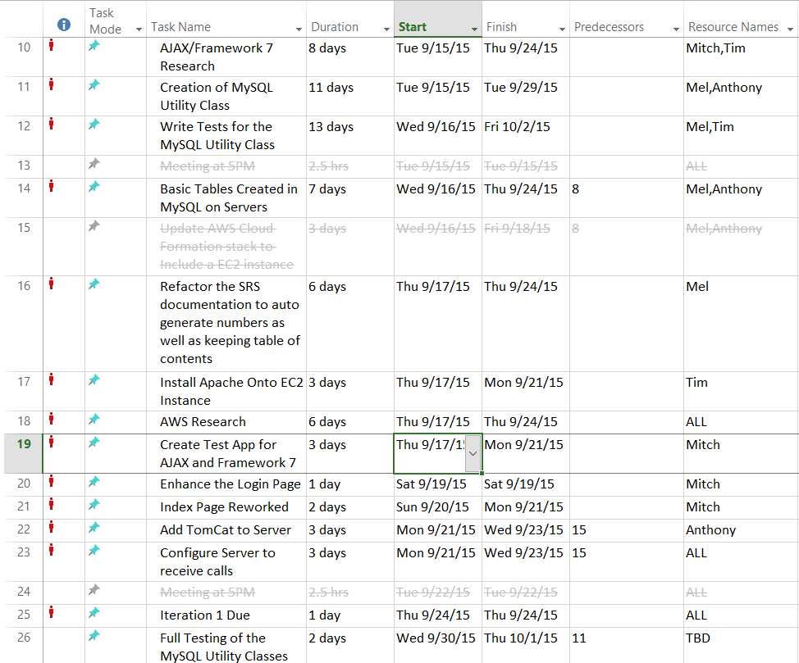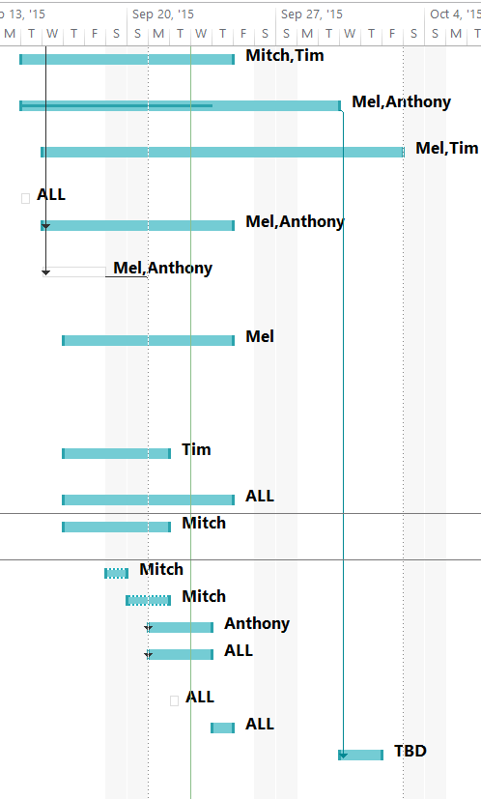

9/19/2015

Updated schedule for addition of unexpected research needed

9/18/2015

Created Microsoft Project instead of using Google Calendar to schedule events

Added project items that we think we will do this week

9/17/2015

Mel has been assigned project manager.